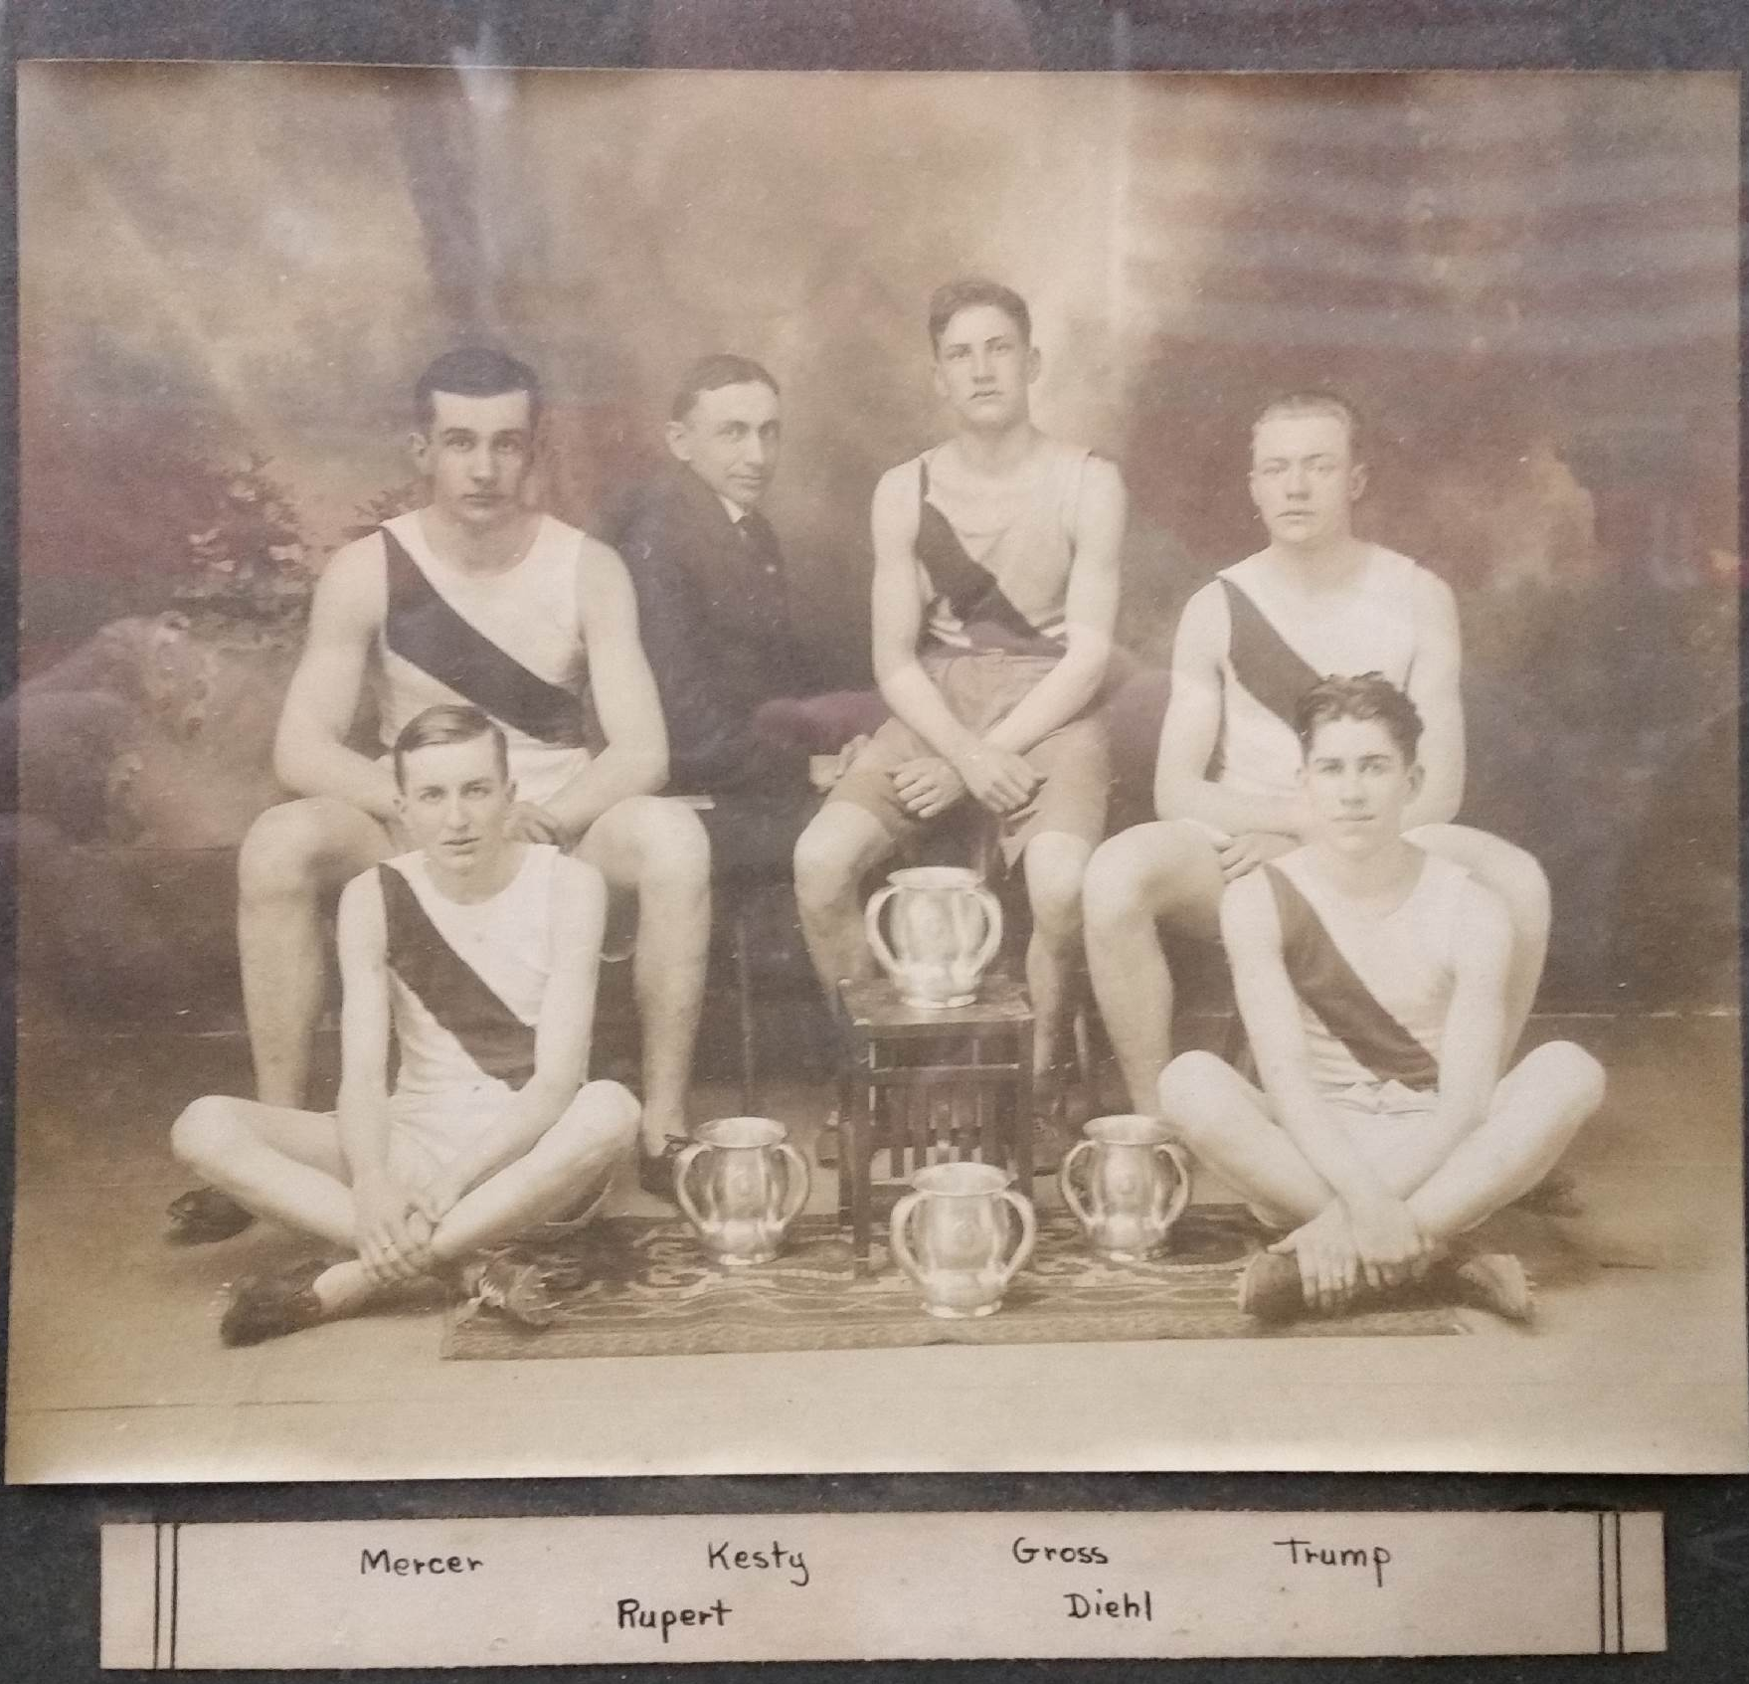
“Lost” in a closet in the family and consumer science room of the Bloomsburg High School for untold years was a treasure that has a number of us in and around BHS quite giddy. A silver prize cup inscribed “1st place high schools” and “University of Pennsylvania, 20th Annual Relay Race Carnival 1914” was unearthed last week and brought to my attention.
This “carnival” is known today as the Penn Relays, the oldest and largest track and field meet held in the United States. The meet dates back to 1885, when the Penn track committee was looking for a special event to dedicate their new athletic stadium, Franklin Field. In 1914, it was already an international event. It started with 64 competitors; today, it boasts over 15,000 competitors. The Penn Relays are the Daytona 500 of track- you win THAT one and you are thought of as something special.
Well, you are thought of as something special if anyone remembers. Did a team of country boys from Bloomsburg in 1914 actually go to Philadelphia and win a relay race against the city kids? No one associated with the school and its track team knew, so it was off to the microfilm of the original Morning Press to find out.
What I found was exciting. Bloomsburg DID compete in the mile relay (four runners each running one full lap) at the Penn Relays in 1914, but reading the articles brought so much more out for me than just facts. It gave great perspective where interscholastic athletics are today. For example, the simple length of time for the trip was much different. In our current days of interstate highways, fuel injected cars, and high-technology radial tires of vulcanized rubber, it is nothing for scholastic sports teams in our area to travel 2 hours in the afternoon, compete, and return the two hours that same day without thought for the journey. (Unless, of course, the back northern tier roads disallow cell reception to the athletes, then the trials of “difficult” travel are vocalized.) The trip to Philly required the team to leave Bloomsburg on Friday morning, run a single Sunday afternoon race, then return late Monday evening.
Another curious perspective made in the articles was that of the track coach, Charles Kesty. Kesty was not actually listed as a coach, but as the “Manager.” His background credentials have also been lost on our generation as Mr. Sterner came from the Steelton YMCA. The Young Men Christian Associations of the day were an entirely different entity, giving lodging and being the center of much athleticism in the early 20th century. Basketball would not be the sport it is today without the YMCA’s teaching its rules and spreading its passion. Steelton YMCA was apparently quite a sports powerhouse, even having a football team that routinely beat college teams in the first two decades of the 1900’s, according to cfreference.net.
So, what of the race itself? There were 8 heats run of the mile relay that year. At large track events, the slowest times are put in the first heat, the fastest times are put in the last heat. Bloomsburg was in the 5th heat, which had these other high schools entered: Mt. Vernon, NY, Pottstown, Mauch Chunk, Schwenkensville, Pottsville, Yonkers, NY, and Hazelton.
Bloomsburg’s Robert Trump ran first and handed the baton off to Eugene Gross. After the second lap, Bloomsburg was in fourth place. Henry Rupert then improved their position and Robert Mercer ran the anchor leg with what must have been an impressive split time as the Bloomsburg for won going away. Considering the nature of the cinder track they ran on, their finishing time of 3 minutes 46 and 1/5 seconds is quite respectable.
The team returned to Bloomsburg with a red and blue colored banner (Penn’s colors) bearing the names of all the competing teams in their heat and the name of the meet. If that still exists, we haven’t been able to locate that anywhere. That would be another treasure for the Bloomsburg community.
Yes, Bloomsburg High School won a race at the world-famous Penn Relays back in 1914! We have a trophy, and now, a story to prove it.

-Todd Davis April 2012

